WORRIED AND SCARED MOM

​

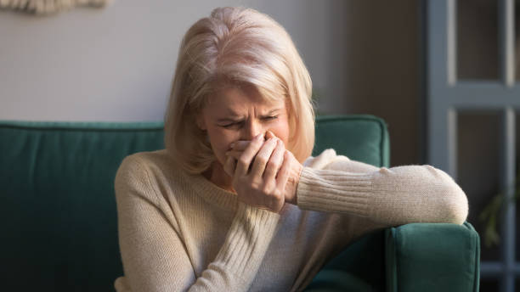

Dear Dr. Al,

My son (25) has problems. Last night he did what he does the worst and drank heavily. His heavy drinking was partly caused by being dumped by his girlfriend. He came home (he’s living with me due to a serious head injury he’s still recovering from - which makes the drinking even worse), and he was hysterical.

He banged up the entire bedroom, threatened to beat me up, and threw a large projectile at my head. Worst of all, he spent hours beating himself and screaming how he wants to die.

For about 3 hours, I hid in fear of my safety and asked his sister and other people to telephone him. He finally calmed down and sobered up. He came out of the bedroom and said, “I have wanted to die since I was 7 years old. Don’t worry, I‘ve grown to live with it and until I make enough money for my family, I won’t harm myself”.

He has told me many times lately of his suicidal thoughts and how his life is meaningless, particularly since his brain got damaged. It’s clearly had an impact with the frontal lobe showing a severe scar.

My dilemma:

The easiest way to keep myself and my home safe is kick him out. It may even be a wake up lesson for him. With that said, in his frail state of mind and his brain injury, it may also mean his last sense of self and value is gone.

What should I do?

Yours thankfully,

Worried and scared mom

Xxxxxxxxxxxxxxxxxxxxxxx

Dear worried and scared mom,

He needs professional help from a specialist. ***MOST*** therapists are not qualified to treat him. I am certainly not qualified to treat him. All my work has been with essentially normal people. All I can do is make a few general suggestions.

1. ***DON'T*** throw him out. I know you are terrified, and I would be also. But if you throw him out, you greatly increase the probability of suicide.
2. Call a few suicide prevention or other crisis hot lines. Some of the people who answer these calls are well-trained. Others will refer you to a well-trained specialist or professional organization.
3. Call local professional organizations that treat alcohol and drug abuse.
4. Call your local Alcoholics Anonymous office. AA has saved millions of lives.
5. He will probably resist getting any treatment. The dominant characteristic of most addicts and disturbed people is denial: "I can handle it. I don't need help." Addictions and mental illness have such strong stigmas that hardly anyone wants to admit they need professional help.
6. The hardest step is the first one: ***Until he admits he needs PROFESSIONAL help, nothing will happen.***

Xxxxxxxxxxxxxxxxxxxxxxxx

Dear readers,

You can see that she really needs help. Maybe you, a relative, or a friend needs similar help. With her permission, I posted her email and my reply on my website's forum. But, as I told her, she needs ***MUCH*** more help than I can provide.

Although she needs help from well-trained professionals, ***your*** comments could also be very useful. She feels isolated, lonely, and helpless. You may have felt that way, perhaps even had a similar situation. She would appreciate your emotional support and any advice you can offer.

If you think you help her, please comment on my forum by clicking **HERE**.

You can use the same link:

* To read comments from other people.
* To ask me or others a question about relationships or any other psychological subject.

Sincerely yours,

Dr. Al Schoonmaker